NEW MEMBER WELCOME PACK

This document has been designed as a good practice editable template for clubs wishing to create their own New Member Welcome Pack. It includes recommended and guideline text covering all the key information you should include, with scope to add additional sections, photographs, website links and tables according to the needs of your club and its new members. If you are using the template or cutting and pasting text, please take time to proof-read and review your final version to ensure that some of the sample text we have provided is not used if you need to change it. You can even use the Front Cover image provided by clicking on it and stretching to the full width and length of your page, to present a modern, fresh and welcoming look to your pack.

1. INTRODUCTION

On behalf of all our members, I would like to extend a warm welcome to your new Golf Club and trust you have will have a long and happy relationship with us.

Your New Members Welcome Pack is designed to make your integration to the club as smooth as possible, providing you with key information to help get you familiar with our facilities and make the most out of your membership package.

I would encourage you to read through the pack to get up to speed with all the relevant information you will need, but if you do have any additional questions please feel free to contact me or speak to a member of staff. Further information can be found via our website or by following our Facebook page.

> Insert website address
> Insert Facebook page

Many thanks for your support and enjoy your golf!

> Insert name of Club Manager / Secretary
Club Manager

2. OPENING HOURS

> Insert your winter and summer opening hours in the table below for each of your main services
Summer (31 March to 31 October)

Day | Clubhouse & Bar | Pro Shop | Catering
Monday
Tuesday
Wednesday
Thursday
Friday
Saturday
Sunday

Winter (1 November to 30 March)

Day | Clubhouse & Bar | Pro Shop | Catering
Monday
Tuesday
Wednesday
Thursday
Friday
Saturday
Sunday

3. KEY STAFF MEMBERS & CONTACT DETAILS

Please find below a list of our key operational staff with contact telephone numbers and e-mail addresses.

Job Title | Name | Contact Number | E-Mail Address
Club Manager
Office Administrator
PGA Professional
Assistant Professional
Bar Manager
Catering Manager
Head Greenkeeper

4. COMMITTEE MEMBERS

Below is a list of our current committee volunteers. Details of other sub-committees can be found on the website. If you are interested in a volunteering role, please contact the Club Manager.

Role | Name | Role | Name
Captain |  | Finance Convenor
Vice-Captain |  | Junior Convenor
Greens Convenor |  | Match & Handicap
Membership Convenor |  | Social Convenor
5. MEMBERSHIP CATEGORIES & INCENTIVES

Our golf club offers a range of membership categories to suit different age groups and lifestyles. We are delighted that you have chosen to join us and hopefully you will become an advocate of the club and encourage friends and family to join.

For all members, we offer a member referral incentive if any of your friends or family join through your recommendation. The current incentive is a 10% discount, based on the value of the new member’s first annual subscription e.g. if a friend joins as an Intermediate Member, you will receive £35 on credit against your next membership fee.

Our current membership categories are as follows:

Category | Age Group | Current Annual Fee
Full Adult | 30 – 65 | £600
Intermediate Adult 1 | 22 – 25 | £350
Intermediate Adult 2 | 26 – 29 | £450
Senior | 65 and over | £525
Youth | 18 – 22 | £250
Junior 1 | 14 – 17 | £150
Junior 2 | Under 14 | £100
Country | Live more than 50 miles away | £300
Social | Over 18 | £50

6. PAYING YOUR MEMBERSHIP FEES

We offer several different options to pay your membership fees:

- Payment facility on our Club Membership App
- Monthly direct debit (spread over 10 months with a 5% admin fee)
- Bar Card top up (you can pay sums of money as you go which go towards next year’s fee)
- Cheque or credit card payment at the office or over the bar

Full details of each option will be e-mailed to you ahead of your annual membership fee payment date, but please contact the Club Manager should you wish to discuss these or change the way you pay your fee next year.

7. CLUB APP & BAR CARD

As a member you will receive a Club Bar Card which entitles you to a 10% discount on all beverage purchases over the bar. This can be topped up at any time at the bar or via your Club App. Your Club Bar Card also has a unique ID number so if you forget your card at any point, you can still use the funds on your card to pay when you tell the bat staff your ID number. Your Club Bar Card can also be used to pay for competition entries.

One of the best ways to connect with the Club is via the new Club APP. This allows you to use your Smartphone to book a tee-time, enter a competition, receive course updates, view leaderboards, check your handicap, top-up your bard card and pay your membership subscription.

> Insert App download details
8. BOOKING A TEE-TIME

We recommend you book tee-times in advance via our on-line booking system, which is available via our website or the club app, although during quieter periods, you can simply turn up and play. As you play more golf, you will know when the peak and off-peak periods are but booking online will guarantee a tee-time.

> Insert link to your booking page

- For general play, tee-times can be booked 14 days in advance
- For competition play, tee-times can be booked 10 days in advance

When booking a tee-time to play with other members, you can search a list of members names and add their name to the booking. This may vary for specified competitions.

You should have received a Club Fixture Book which features the dates of all our club competitions across all categories and this is also available via the website and the Club App. A typical week during the season is as follows:

Day | Competition Type | Competition Tee-Times
Monday | Ladies Midweek | 1000 – 1200; 1500 - 1630
Tuesday | Seniors | 0900 – 1030; 1400 – 1500
Wednesday | Gents Midweek | 1000 – 1200; 1500 - 1630
Thursday | Mixed | 1600 - 1800
Friday | No competitions | N/A
Saturday | Gents & Ladies | 0730 – 1400
Sunday | Juniors | 1400 – 1530

Visitor bookings will be notified on the online booking system.

9. MEMBERS GUEST FEES

As a Club Member you are entitled to 12 x Members Guest Fees per year at the discounted rate of £15 per player. When booking a tee-time with a guest online, simply add ‘Guest’ to your booking and you will have the option of playing with 3 guests per slot. You can pay in advance online via the website or App or pay the green fee in the Pro Shop before you play.

10. PLAYING IN COMPETITIONS

Our Club is committed to offering competitions to golfers of all ages, abilities and genders. We aim to make competition golf as inclusive as possible and the handicap system means players at all levels can compete against each other. Playing regular competitive golf is a great way of improving your game, getting your handicap down, keeping your competitive juices flowing and hopefully winning a few prizes along the way!

While we have different competitions for different categories, we encourage all golfers to play together, with most Saturdays dedicated to competition play for all levels with mixed tee-sheets open to men, women and juniors. We offer a great mix of events, from the traditional stroke play competitions to fun scrambles, as well as knock-out match play, shotgun starts, team matches and 9-hole events.
All competition fixtures are listed on the website and Club App. To book and play in a competition, simply follow the steps below:

- Tee-times for competitions are available 10 days in advance and go live at midday;
- Select the competition you wish to play and book your slot – you can add fellow members;
- On the day of play, you can pay your entry fee via the Club App or at the terminal in the clubhouse;
- Collect your card from the Pro Shop and add your name/handicap to the card;
- Join your playing partners on the 1st tee and swap your cards;
- On completion of your round, put your hole-by-hole scores into the terminal, make sure you have signed your card together with your marker’s signature and put into the slot beside the terminal;
- The competition results will be posted on the Club App and website once the competition is closed.

If you are unfamiliar with the process, don’t be afraid to ask a fellow member for help or ask the Pro to take you through the steps required at the Club Terminal. It’s easy once you get the hang of it!

11. MATCH PLAY COMPETITIONS

> Insert details of any match play competitions and the entry process, as well as what is required to arranged to play matches. Many club software companies now offer online or app entries for match play competitions, as well as having the draws online in addition to the club noticeboard. Add a table of your match play competitions:

Competition | Category | Description
Summer Singles | Gents
Club Four-Ball Better-Ball | Gents
Mixed Foursomes | Gents & Ladies
Senior Singles | Senior Gents
Senior Pairs | Senior Ladies

12. CLUB MATCHES

> Insert details of any team matches for all categories e.g. Women’s, Men’s, Seniors, Juniors and ‘Elite’. Include the process of putting your name forward for selection for a team match or any selection criteria. If your fixture dates are confirmed, include them in a table or feature a link to the relevant page on the website. If relevant, you could also include the names of the respective team captains, and an image of one of the team’s e.g. if they have recently won a trophy or your want to promote the team kit or sponsor. Including a summary will help your new members identify which teams would be appropriate for them:

Team | Description
Men’s | A mix of friendly matches and the regional ‘elite’ league
Ladies | A mix of friendly matches and the regional ‘elite’ league
Juniors | A mix of friendly matches and the regional ‘elite’ league
Seniors | A mix of home and away friendly matches against local clubs

13. HANDICAPS

In order to compete in a club competition, you must have a valid and up to date handicap. Members transferring in or players who are members of other clubs but wish their “home” club nominated as this one should obtain their latest handicap certificate from their former club and post it through the office door with an explanatory note.

To obtain a new handicap, or to reinstate a lapsed handicap, three cards must be handed in – clearly marked “for handicap”. This can be done as 3 x rounds of 18 or 6 x rounds of 9 holes. At least one of these cards should be from playing from medal tees, and all cards must be marked and signed by a member who has a valid handicap.

Members are responsible for reporting “away” scores as soon as possible after the event they have played in and are therefore responsible for playing off the correct handicap at all times. The Club App will allow you to check your up-to-date handicap.

Our club feeds scores into the Scottish Golf Centralised Database of Handicaps (CDH). Every member with a handicap will be given a CDH number. Please ensure you provide your CDH number when entering competitions ‘away’ from home. This will keep your handicap up to date when playing away competitions.

To find out more about handicapping and the forthcoming changes to the new Worldwide Handicapping System (WHS), please visit the Scottish Golf website:

> https://www.scottishgolf.org/club-services/handicapping/

14. SOCIAL EVENTS

The Club runs a number of social events throughout the year which are open to all members with the opportunity to invite guests along to enjoy them with you. These range from Theme Nights designed by our catering team, family quiz nights, our annual Burns Supper, presentation nights and Christmas Parties. We have a social sub-committee who work hard behind the scenes to plan these events and we are always open to suggestions to create new events to attract more members to our social events.

The aim of our social nights is to create a good atmosphere in the clubhouse, generate bar and catering revenue and encourage members and their guests to socialise with each other.

Our social events are listed on our website and will be communicated in advance through our Club newsletter, with relevant ticket prices and booking details.

> If you have regular events which are typically part of your annual calendar, you may wish to include a summary table below:

Date | Event
Burns Supper | Saturday 25 January – ticket price £20 per head
Family Quiz Night | Friday 6 March – ticket price £5 per head (includes buffet)
Mother’s Day Lunch | Sunday 22 March - £15 per head set menu
Masters Sunday | Sunday 11 April - special American menu
Summer BBQ | Saturday 31 May
Club Championship Finals | Saturday 21 June

15. BOOKING A FUNCTION

One of the great benefits of being a member of our Golf Club is the opportunity to host your own event in the clubhouse, with no room hire costs for members. This could be a special birthday such as your 21st or 70th, an anniversary, a Christening or even a wedding.

Our catering team offer a fantastic menu of event packages with a range of price options to suit your budget and number of guests.

To make a booking, please contact the Catering Manager in the first instance and they will be happy to discuss your requirements and look at available dates for you. We recommend you book at least 3 months in advance.

> If you have a nice image from a previous function you could include it here to bring this section to life and show the member what their event could look like

> Function Image

16. BAR & CATERING

Our Clubhouse has a great bar offering the perfect environment for your post round pint, glass of wine, soft drink or Latte. We have a big screen with a Sky Sports subscription showing live sport all year long, including regular European and PGA Tour events, golf’s Majors and Premiership and SPLF football coverage, with a few catering themed offers thrown in around some of the big events.

We have a fantastic range of drinks available, from the Club Lager to our guest Gins and Whiskies and our recently installed Barista hot drinks machine provides a welcome addition for your choice of morning coffee or afternoon tea. The bar and lounge also have free Wi-Fi, which is perfect for kids or if you work remotely and ever want to pop for a change of scenery from your home office!

The catering team offer an excellent range of breakfast, lunch and dinner menus with a great selection of food, whether you’re looking for a bacon roll before your round, refuel after a game of golf, lunch with friends, romantic dinner or group night out.

> Insert website link to full menu or club catering page

If you want to book a table in the lounge, please call 01234 567890 (Ext. 3)

Sample Menu:
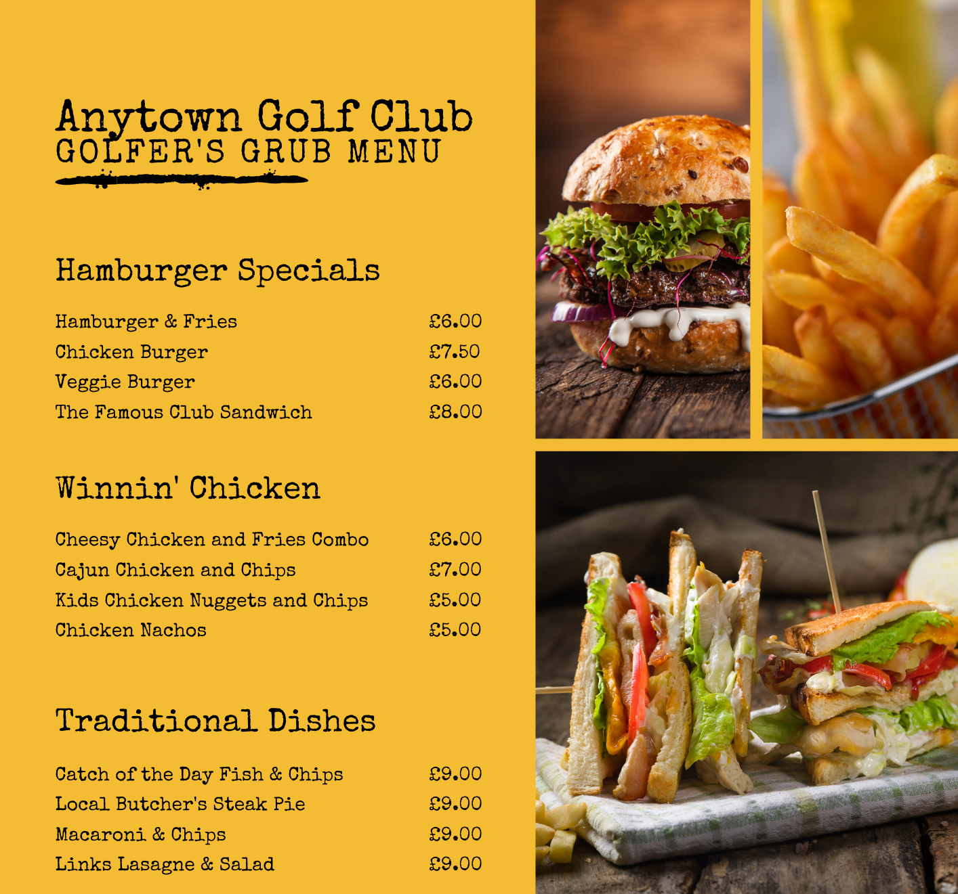17. LOCKERS & CADDY STORE

Lockers are available for annual hire although there is currently a waiting list. If you would like to put in the queue, please send an e-mail to the Club Manager and we will be in touch when one becomes available. The annual cost is £30.

We also offer a Caddy Store for your power caddy if you have one. Annual rental for a space is £25 and we currently have a few available for the new season. If you would like to book one, please send an e-mail to the Club Manager.

Trollies and Power Caddies are available for hire from Pro Shop. The codes for the Locker Room and Caddy Store will be included in your introductory e-mail from the club.

18. DRESS CODE

We have a relaxed dress code at the club and encourage you to wear what you are comfortable playing golf in and socialising. The only restrictions are not wearing wet waterproof clothing in the bar or lounge areas as this may cause damage to the furniture, and no football colours are allowed. Soft spike golf shoes are allowed in the bar.

> You may have stricter dress codes which you wish to include but we recommend any narrative around dress codes is done in a positive tone rather than what people perceive to be very stuffy, traditional and constant use of the word No, as this may put new or some younger members off.

19. MOBILE PHONES, SOCIAL MEDIA & WIFI

Mobile phones are part of everyday life, but we ask that you keep your phone on silent on the course and in the clubhouse. We encourage our members and visitors to post photographs, videos, check-in and add reviews on our social media to help promote the club to wider audience and share your good experiences at the club. We offer free Wi-Fi with the password available from the bar staff.

You can follow our social media channels below:

Facebook: | Instagram: | Twitter:

20. RECIPROCAL GOLF AT OTHER COURSES – DISCOUNTED GREEN FEES

As an additional benefit of membership, we are pleased to offer the opportunity to play other courses at discounted green fee rates, thanks to our reciprocal agreements that we have in place. Discounts and booking restrictions vary from course to course, but these agreements provide a great way to experience new courses and add great value to your membership.

These offers are summarised in the table below and can be booked by following the instructions listed. We recommend you take your Membership Card with you at all times to use as proof of membership when you visit, while observing the Terms & Conditions of booking at each partner club.

Name of Club | Special Offer Fee | Booking Details
Anytown Golf Club | £12 - member guest rate | Call Anytown Golf Club quoting our Golf Club Name. Tuesdays and Thursdays only after 1pm
Random Golf Club | £15 – maximum of two rounds per year | Book through our Club Manager. Only available on Mondays.
Partner Golf Club | 3-ball for £30 – must all be members | Monday to Friday afternoons only. E-mail Partner Golf Club secretary.

As a member of an affiliated Scottish Golf club, other special offers are also available throughout the year at selected Scottish courses. Visit the scottishgolf.org to find out more and register for the Golfers Newsletter to receive the latest course offers.

> https://www.scottishgolf.org/

20. PRO SHOP

Last but certainly not least we are delighted to introduce our Pro, {insert name here} and his / her assistant, {insert name here}.

We have a fully stocked Professional Shop with fully qualified PGA staff on hand to offer expert advice on coaching and equipment, including:

- Custom fit service with some of the leading brands in golf
- Trackman technology
- 1:1 coaching including video and on course lessons
- Club repair and regripping service
- Clubs, bags, shoes and other accessories
- Exclusive club branded apparel from leading brands
- Group coaching for beginners and seniors
- Junior coaching programme
- Gift vouchers

You can access coaching hints and tips via our Pro’s YouTube channel – subscribe now via the link below:

> Insert Pro YouTube Channel URL

21. KEEP IN TOUCH!

We value your input, so if you have any questions or feedback on your new member experience then please contact get in touch.

